**TC017 – Fetch Booking data filtered by checkin / checkout dates**

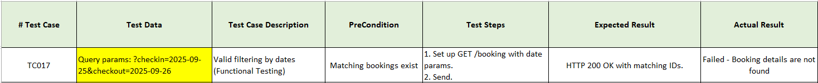

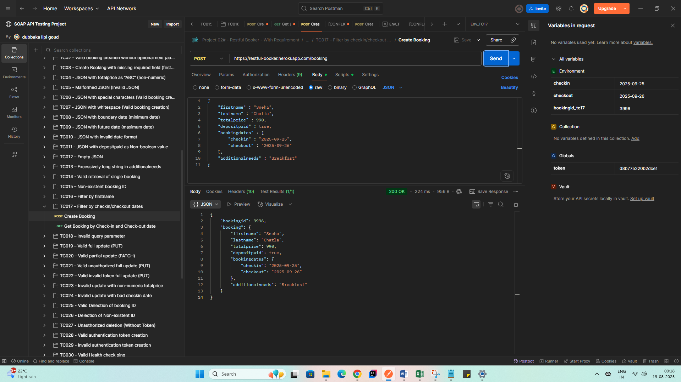

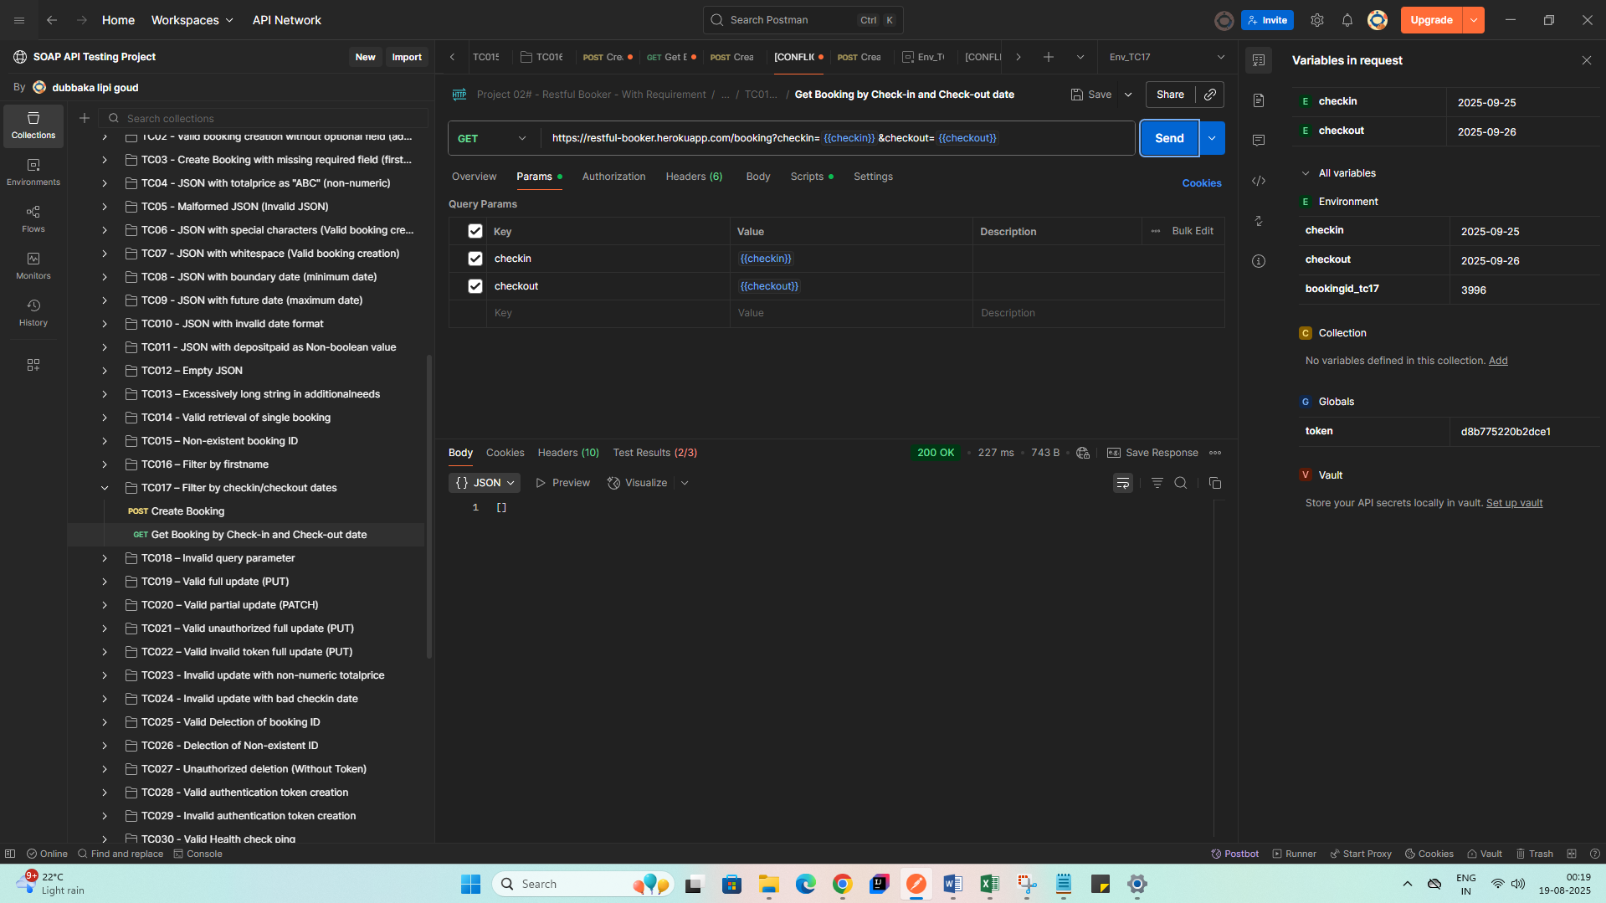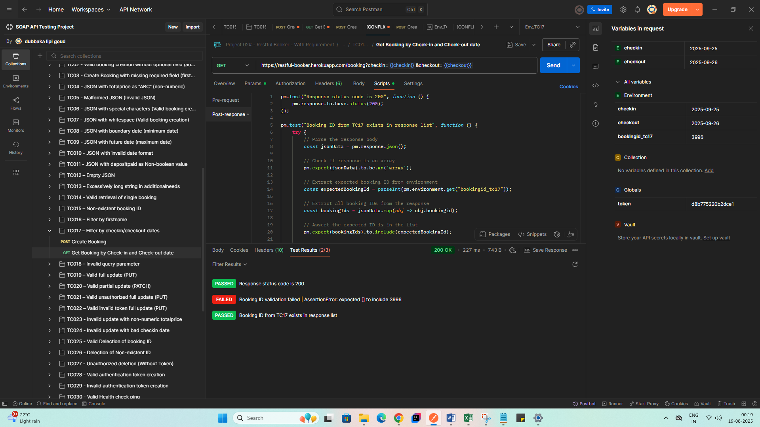

**Bug:** API fails to retrieve booking using valid check-in and check-out date filters

Test Steps:

1. Send GET request to /booking with query parameters:  
   ?checkin=2025-09-25&checkout=2025-09-26
2. Observe the response.

Expected Result:

* API should return HTTP 200 OK with booking ID 3996 (or any matching booking).
* The response should include booking(s) with the specified date range.

Actual Result:

* API returned HTTP 200 OK, but no bookings were returned.
* Booking ID 3996, which matches the filter criteria, was not found in the response.